Jyorish Sainju

Southern New Hampshire University

CS 330 – Computer Graphic and Visualization

20 March 2024

For this assignment, I decided to go with the items on my computer table and incorporate them into the design. This is one of the reference pictures I submitted in module two.

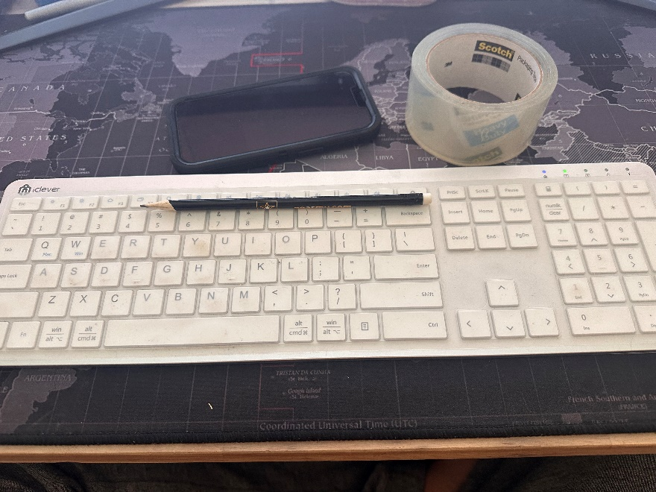

To begin, I opted to repurpose a plane as the foundation for my computer table and used a white wooden texture to complete its look. The components utilized in my design predominantly feature box meshes, with a few exceptions such as the scotch tape and pencil. Additionally, I opted to include a computer screen in the background to provide a comprehensive perspective of the computer table. As previously mentioned, the keyboard and cell phone are constructed using basic box meshes, with the keyboard wrapped with a keyboard texture and the cell phone finished in a plain metallic black color shade.

The pencil is designed from a combination of a cone and cylinder mesh. Layering the cylinder creates the body of the pencil, while an eraser is appended at one end. The tip of the pencil comprises two layers of cones: one shaded in plain black to simulate lead, while the other is textured to resemble wood. The creation of the pencil required the use of four distinct shapes.

The scotch tape employs a single-layer cylinder mesh to achieve its characteristic appearance. Although attempts were made to add additional layers to enhance its girth, these were ultimately discarded due to unforeseen challenges. Consequently, the scotch tape is depicted as a single-layer cylinder mesh with a glossy surface to evoke its reflective properties.

The computer screen is constructed from a blend of three box shapes and a cylinder. Two box shapes are utilized to form its base, with a cylindrical shape employed to use as a stand, and an additional box shape serves as the screen area. Previously used plane mesh is added to the background to form a wall, textured with a drywall finish. By Combining these shapes, I was able to faithfully recreate the items on my computer table, resulting in the final design presented herein.

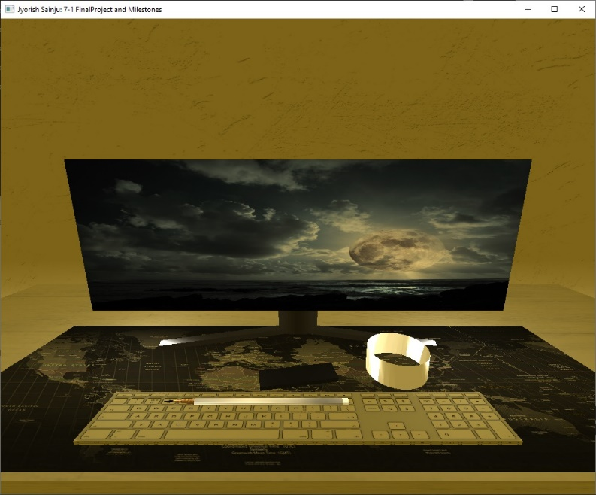

During the course, I encountered numerous challenges, each serving as an opportunity to step out of my comfort zone and immerse myself in a whirlwind of research and trial and error. Whether I turned to YouTube videos or utilized the OpenGL website which was a resource throughout the class, I engaged in a continuous process of exploration and experimentation to overcome obstacles. An unforeseen challenge I encountered revolved around using colors in RBGA format. Initially, I attempted to utilize a color picker tool to select the precise shade I desired. However, this approach did not yield the expected results, prompting me to resort to a more brute-force method. I experimented with random numbers until I eventually arrived at the desired shade. This process was time-consuming and required persistence, but ultimately allowed me to achieve the desired outcome.

Another challenge arose during the design of the scotch tape. Initially, I attempted to create the tape by using multiple layers of cylinders with varying sizes to achieve the desired thickness. However, this approach did not produce the outcome I had in my mind. This is a huge setback since it was part of my final project and still not yet complete with the look I want. I am determined to continue refining my skills beyond the assignment to further enrich my learning experience.

Designing the pencil turned out to be less complex than I initially anticipated. However, achieving the right balance in proportion and size posed its own set of challenges. Additionally, I am keen to incorporate shadows cast by the items in the scene, taking into account the position of the light source. Exploring the interplay between shadows and camera angles as the viewing perspective changes promises to add depth and realism to the overall composition.

Despite the challenges encountered, I found the project to be incredibly engaging and rewarding. Each obstacle presented a unique learning opportunity, pushing me to explore new techniques and problem-solving strategies. While overcoming these challenges required considerable effort, I ultimately achieved the results I had visualized for the project.